Translation of Fiori Catalogs and Groups:

Go to SE63 – Select Short Texts:

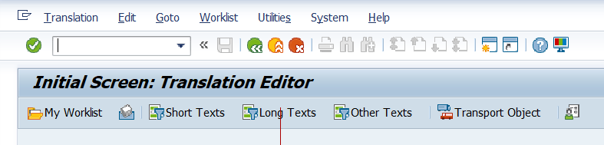

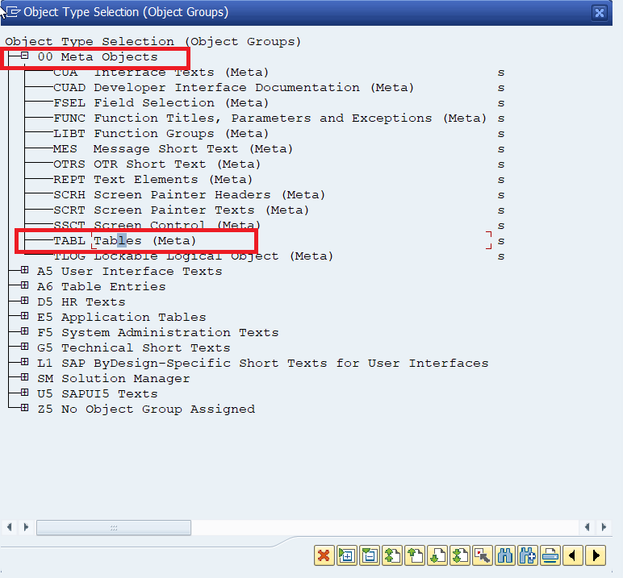

Give the name of the Catalog or Group with asterisks

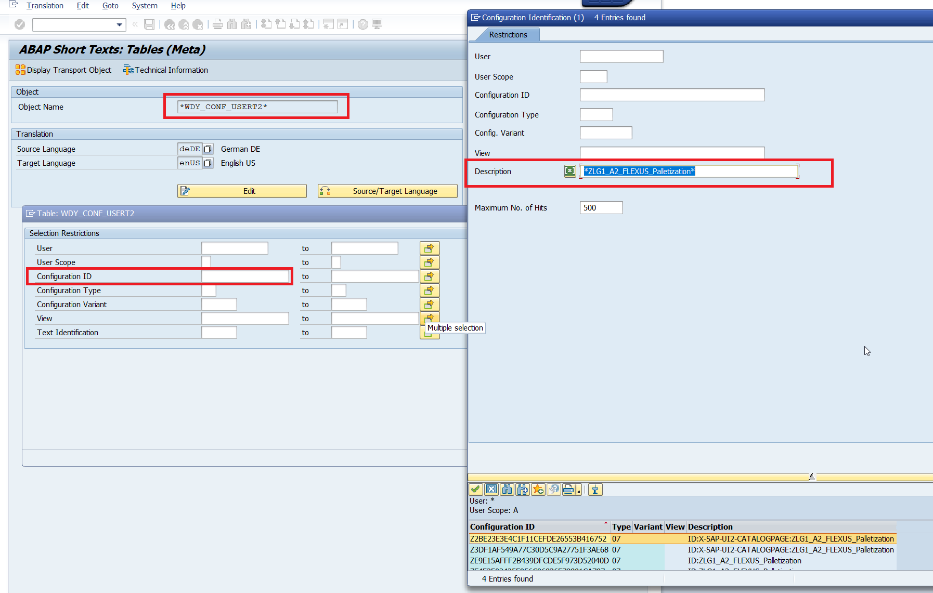

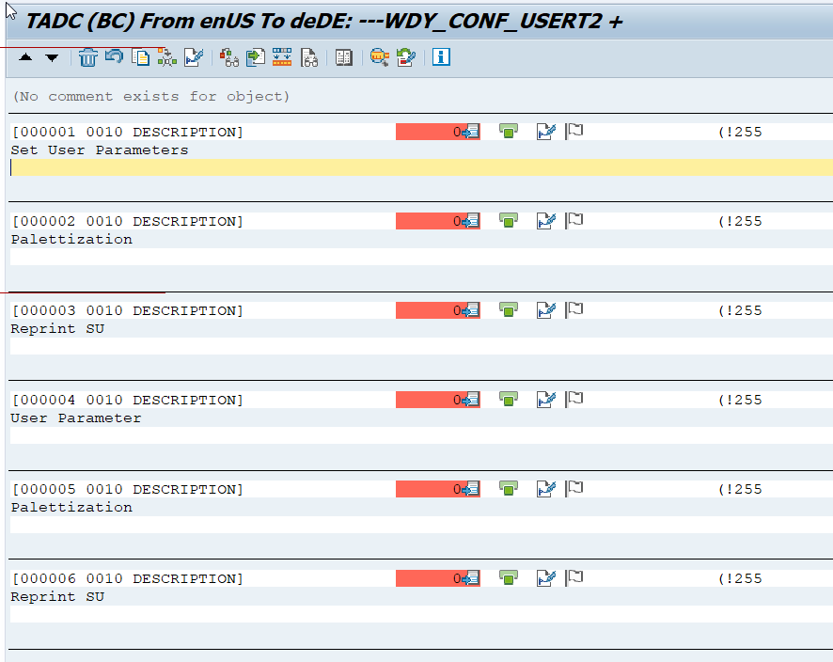

After translations move it to a Transport Request via transaction SLXT

Clear the Cache through Report  /UI2/INVALIDATE_GLOBAL_CACHES

Test our translation for any language by using URL parameter (sap-ui-language).To do so, just append “?sap-language=xx” to your application URL.